Introducing Flavor in eShiksha App

Plugin : flutter_flavorizr: ^2.2.3 #for flavorizer

Define Flavor attribute in the pubspec.yaml

flavorizr:
app:
android:
flavorDimensions: "eshiksha"
flavors:
maincommon:
applicationId: "com.lrtechnologypvtltd.lrschool"
school1:
applicationId: "com.lrtechnologypvtltd.lrschool.school1"
ios:
flavors:
maincommon:
bundleId: "com.lrtechnologypvtltd.lrschool"
school1:
bundleId: "com.lrtechnologypvtltd.lrschool.school1"
flavors:
maincommon:
app:
name: "eShiksha"
icon: "assets/app_icons/1.png"
school1:
app:
name: "School 1"
icon: "assets/app_icons/school1.png"
instructions:
- remove: ios/Runner/Assets.xcassets/AppIcon.appiconset
- image_assets:
flavor: maincommon
path: "assets/app_icons/1.png"
- image_assets:
flavor: school1
path: "assets/app_icons/school1.png"

note : to add new flavour just do same as done for school1

Adding the package in build.gradle
flavorDimensions "eshiksha"
productFlavors {
maincommon {
dimension "eshiksha"
applicationId "com.lrtechnologypvtltd.lrschool"
versionCode flutterVersionCode.toInteger()
versionName flutterVersionName
}
school1 {
dimension "eshiksha"
applicationId "com.lrtechnologypvtltd.lrschool.school1"
versionCode 1
versionName "1.0"
}
}

for new flavour add same as school1

make a director of the flavour :
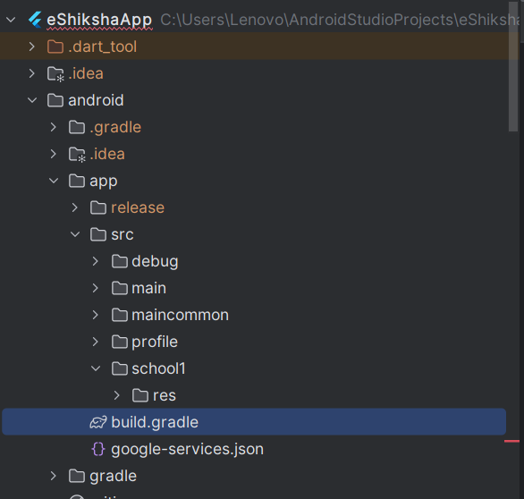

In which under res give values/string.xml for app name
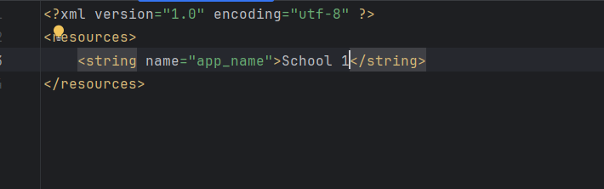

For App Icon :
Using plugin : flutter_launcher_icons: ^0.14.1 #for flavor launcher icon

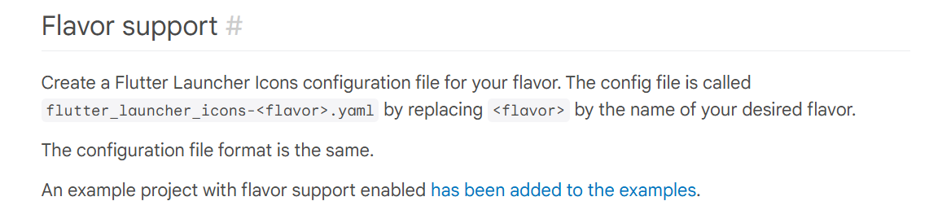
Based on this :


Which contains
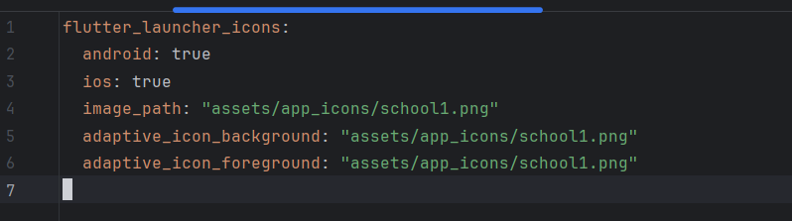
And run command:
dart run flutter_launcher_icons:main -f flutter_launcher_icons*
and we are done !!!

To run the flavour us

Flutter run –flavor flavour_name -t lib\file_name.dart

